- Janamejaya:-

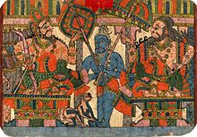
The sage Vyasa and King Janamejaya
Predecessor | Parikshit
Successor | Aswamedhadatta
Children | Śatáníka
Parent(s) | Parikshit (father)  Madravati (mother)

